**Draw an ER diagram for the given scenario;**

1. Suppose that you are designing a schema to record information about reality shows on TV. Your database needs to record the following information:

_ For each reality show, its name, genre, basic_info and participants name. Any reality show has at least two or more participants.

For each producer, the company name, company country. A show is produced by exactly one producer. And one producer produces exactly one show.

_ For each television, its name, start year, head office.  A television may broadcasts multiple shows. Each show is broadcasted by exactly one television.

_ For each user, his/her username, password, and age. A user may rate multiple shows, and a show may be rated by multiple users. Each rating has a score of 0 to 10.

2. Convert the following ER diagram to set of relational schemas.

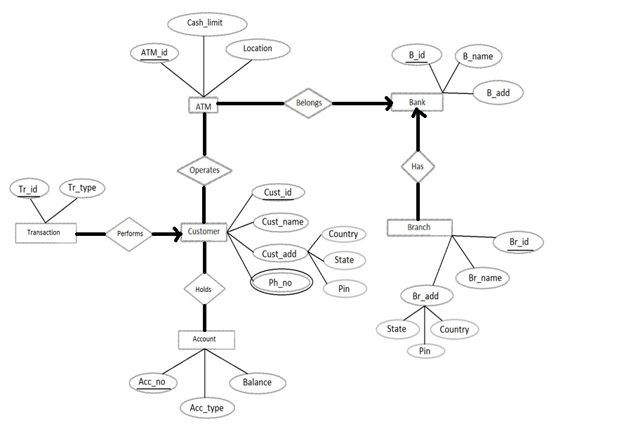

Identify Strong entity sets and underline primary keys

Identify composite attributes

Multivalued attribute

Relationship sets.